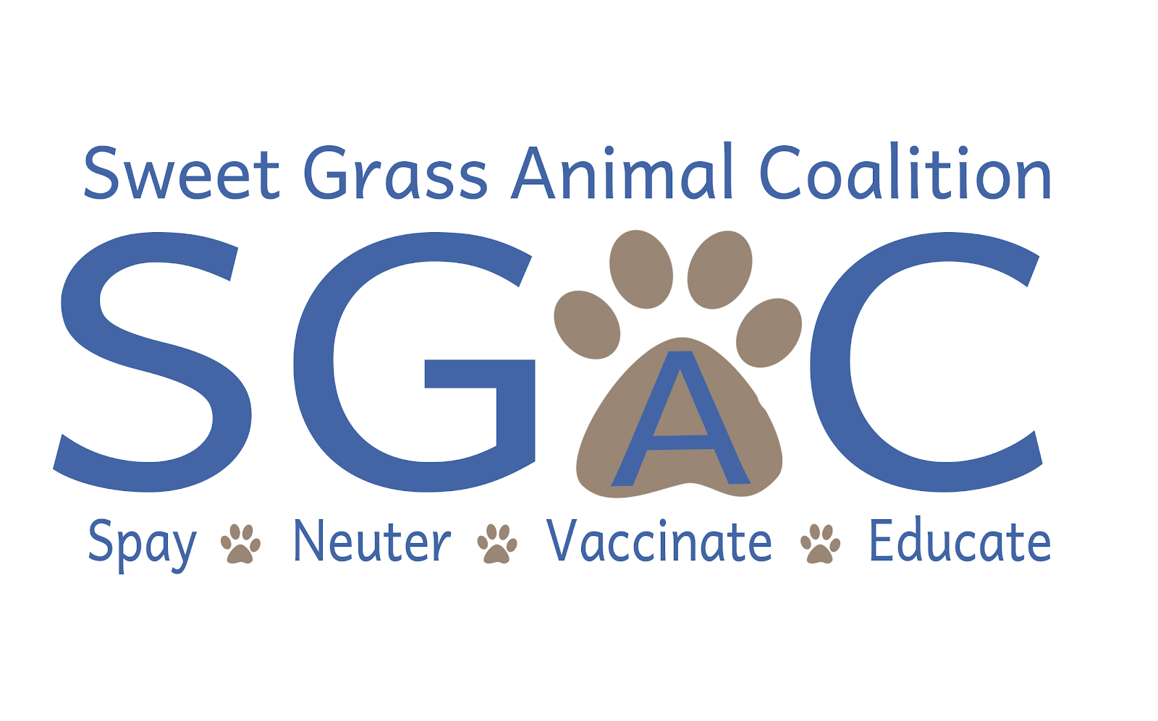
Scholarship Information and Application

Sweet Grass Animal Coalition’s mission is to reduce the number of unwanted animals entering shelters by educating the community, offering trap/neuter/release programs and holding low-cost spay/neuter/vaccination clinics. We are passionate about eliminating the overpopulation of homeless animals, and through our efforts, we are creating healthy animal populations in our community.

We will be awarding two $1,000 scholarships—one to a graduating senior at SGHS and another to an SGHS graduate who is currently enrolled in college. Scholarship applications and materials must be e-mailed to sganimalcoalition@gmail.com by
March 27, 2026. Funds will be sent directly to the school you are/will be attending.

Eligibility Requirements:
-SGHS Senior or SGHS Graduate currently enrolled in college
-Pursuing a degree related to biological sciences or veterinary medicine
-Involvement in community service/volunteer activities outside of school-
affiliated activities

Full Name: ________________________________________________________
Address: __________________________________________________________
E-Mail Address: ____________________________________________________
Mobile Ph #: _______________________ Current GPA: _____________

College Name: _____________________________________________________
Financial Aid Office Mailing Address: ___________________________________
City, State, Zip: _____________________________________________________
Major: ___________________________________ Student ID: _______________

Please answer the questions below on a separate document.
1. List all activities/organizations that you have participated in outside of high school-
affiliated activities (include hours/years involved and position(s) held, if applicable).
2. Briefly explain why you have chosen this field of study.
3. Please attach a current resume.

